1. What are the two values of the Boolean data type? How do you write them?

Ans: TRUE and FALSE are two values of the boolen data types. We have to use capital T and F with the rest of the word in lowercase.

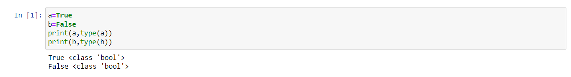

1. What are the three different types of Boolean operators?

Ans: The three different types of Boolean operators in python are: OR, AND, NOT

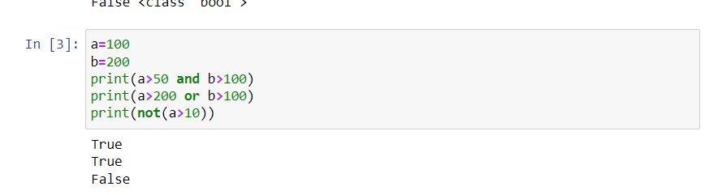

1. Make a list of each Boolean operator’s truth tables(i.e every possible combination of Boolean values for the operator and what it evaluate).

Ans: The truth tables for the Boolean tables are as follows:

**Truth Table for AND Operator**

True and True is True

True and False is False

False and True is False

False and False is False

**Truth Table for OR Operator**

True or True is True

True or False is True

False or True is True

False or False is False

**Truth Table for NOT Operator**

True not is False

False not is True

1. What are the values of the following expression?
   1. (5>4) and (3==5)
   2. Not (5>4)
   3. (5>4) or (3==5)
   4. Not ((5>4) or (3==5))
   5. (True and True) and (True == False)
   6. (not False) or (not True)

Ans: 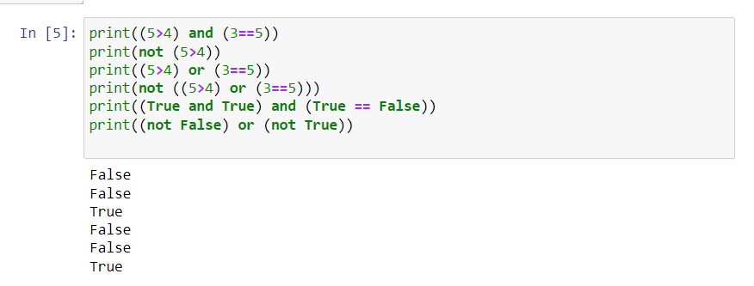

1. What are the six comparison operators?

Ans: The six comparison operators available in python they are:

==, !=, <,>, >=,<=

1. How do you tell the different between the equal to and assignment operators? Describe a condition and when you would use one.

Ans: == is the equal to operator that compares two values and evaluates to a Boolean, while = is that assignment operator that stores a values in a variable.

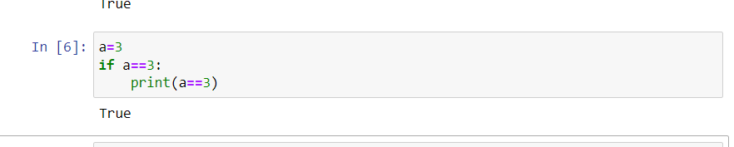

1. Identify the three blocks in this code:

spam = 0  
if spam == 10:  
print('eggs')  
if spam > 5:  
print('bacon')  
else:  
print('ham')  
print('spam')  
print('spam')

Ans: In python, code block to a collection of code that is in the same block or indent. The is most commonly found in classes, functions, and loop

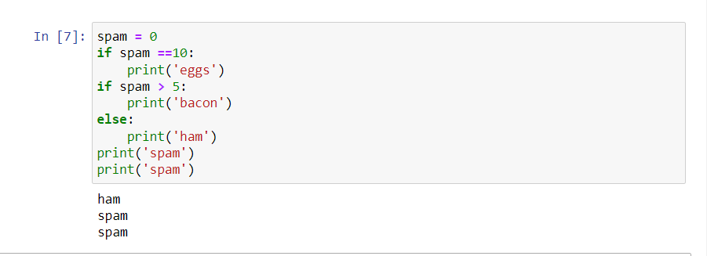

1. Write code that prints Hello if 1 is stored in spam, prints Howdy if 2 is stored in spam, and prints Greetings! If anything else is stored in spam.

Ans: 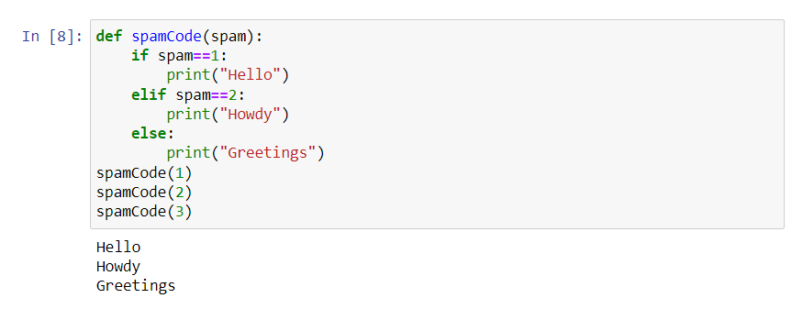

1. If your programme is stuck in an endless loop, what keys you’ll press?

Ans: Press Ctrl-C to stop a program stuck in an infinite loop

1. How can you tell the different between break and continue?

Ans: The break statement will move the execution outside the loop if break condition is satisfied. Whereas the continue statement will move the execution to the start of the loop.

1. In a for loop, What is the different between range(10), range(0,10), and range(0,10,1)?

Ans: The Difference are as follow:

* 1. The range(10) call range from 0 to 9 (but not include 10)
  2. The range(0,10) explicitly tells the loop to start at 0
  3. The range(0,10,1) explicitly tells the loop to increase the variable by 1 on each

1. Write a short program that prints the number 1 to 10 using a for loop. Then write an equivalent program that prints the number 1 to 10 using while loop.

Ans: 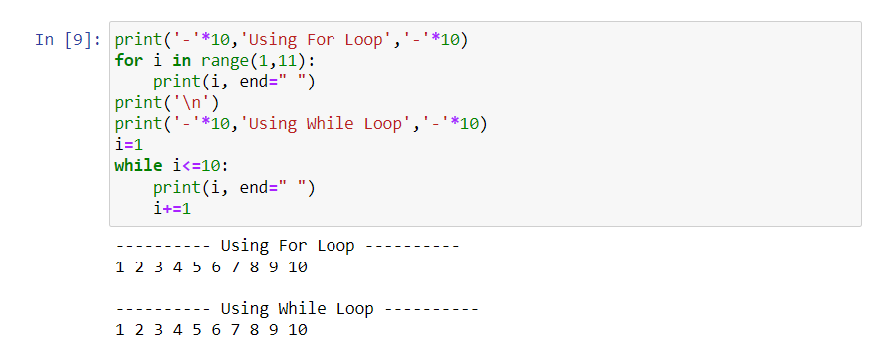

1. If you had a function named bacon() inside a module named spam, how would you call it after importing spam?

Ans: This function can be called with spam.bacon()